  - Kawasaki KLR 650 Skid Plate Installation

- Using an 8mm Socket or T-Handle Wrench, Remove the 4 Hex Head bolts holding the plastic stock skid plate on. There are 2 on the bottom. (Fig 1) and two in the front of the skid plate. (Fig 2) Remove plastic skid plate
- Line up your New Enduro Engineering Aluminum Skid Plate to the existing mounting holes.
- With the 4 provided M6x16 bolts and flat washers, start two of them by hand in the two front mounting holes of the existing wings, (Fig 3) and two of them in the bottom two mounting holes, (Fig 4)
- Using your 8mm Socket or T-Handle Wrench again, tighten the 4 M6x16 bolts started in the previous step. Hold the EE Aluminum skid plate tight to the frame with one hand a rotate tightening bolts front to back
- Your New Enduro Engineering KLR 650 Skid Plate is now ready for your next Adventure. Have Fun & Ride Safe! (Fig 5)

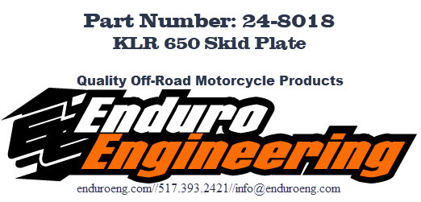
WARNING AND DISCLAIMER
All parts manufactured, designed or sold by Enduro Engineering, Inc. (EEI) are to be installed by a licensed motorcycle dealer or a licensed motorcycle technician, Motorcycles can be dangerous. Serious injury, death and property damage can result from the use of motorcycles. This risk is increased by improper installation or misuse of after marker parts. EEI’s customers must exercise good judgement in the use, control, alteration, part selection and installation, and maintenance of their motorcycles. In the event of a possible defect in material or design, or any other defect in a part manufactured, designed or sold by EEI, the responsibility of EEI is limited to either a refund of the purchase price or the replacement of the part if EEI determines the part to be defective, and subject to EEI’s inspection of the part within thirty (30) days from the date of purchase. (Note: any attempted repairs or modifications made to EEI Products will void this limited warranty.) EEI, under no circumstances will be responsible for incidental and/or consequential damages, property damage, personal injury damage, or damage, injury, cost or expense of any kind or nature whatsoever. By purchasing as EEI product or a product sold by EEI, you (1) acknowledge the above disclaimer and agree to its terms; (2) agree that any claim brought against EEI arising from and/or pertaining to or otherwise related to a part manufactured, designed or sold by EEI must be brought in the Michigan State Courts located in the County of Ingham or in the Federal District Court for the Western District of Michigan and the Michigan law shall apply on all issues; and (3) any claim against EEI must be brought within one (1) year of purchase of the product. EEI makes no other warranty, express or implied, including without limitation any warranties of merchantability and fitness for a particular purpose.

